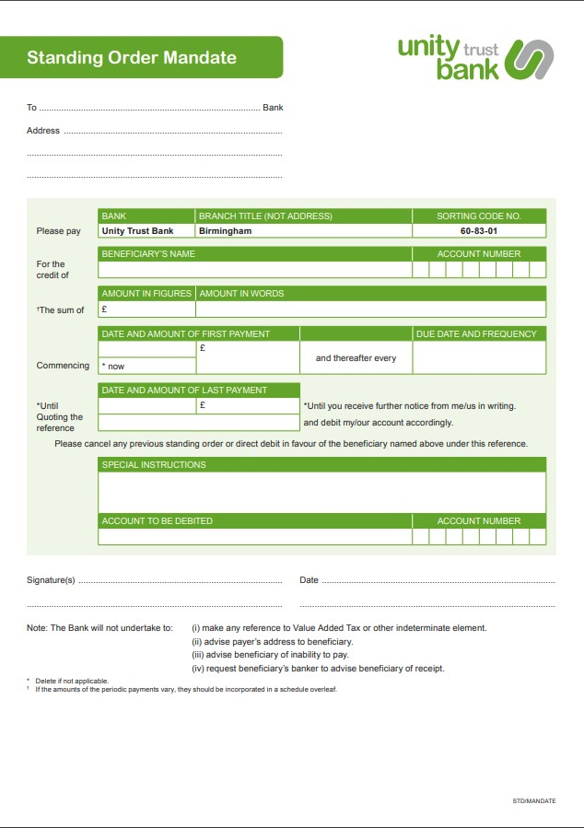

LEICESTER UNEMPLOYED WORKERS CENTRE LIMITED

2

0

3

9

5

4

3

6